

GITAM Bengaluru Campus, NH 207, Nagadenahalli Doddaballapura

Taluk, Bengaluru Rural District-561203

“**Ultrasonic Mosquito Repellent**”

Sri Sagar A

2024203703

MTech in VLSI Design

Technical Seminar

Ultrasonic Mosquito Repellent

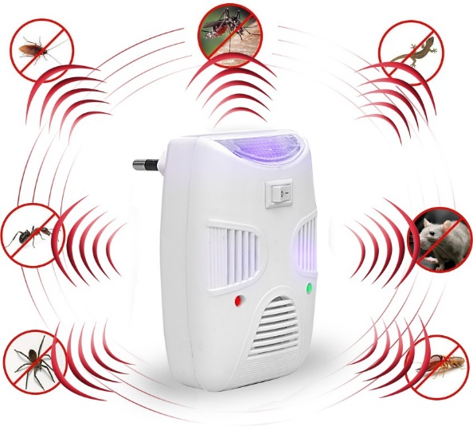

Figure Ultrasonic Mosquito Repellent

* What is Ultrasonic Mosquito Repellent?

Ultrasonic mosquito repellents use high-frequency sound waves, above human hearing, to deter mosquitoes, aiming to disrupt their sensory perception. Though marketed as safe and convenient, their effectiveness is widely debated and not consistently supported by scientific evidence.

* How it works ?

This circuit uses a 555 timer IC in astable mode to generate an oscillating signal. The frequency, adjustable via a variable resistor, is set in the ultrasonic range (20-38 kHz). This signal drives an ultrasonic transducer (not shown), producing high-frequency sound waves. The theory is that these sounds disrupt mosquito sensory perception, potentially repelling them. However, the actual effectiveness of such devices is scientifically debated.

* What’s the purpose of it?

This circuit intends to repel mosquitoes by generating ultrasonic sound waves using a 555 timer IC. It creates high-frequency sound, beyond human hearing, theorized to disrupt mosquito behavior. While non-chemical, its effectiveness is scientifically debated

Table of contents

List of Figures 4

List of Tables 5

1. Introduction: 6

2. Working Principle: 6

3. Component Selection: 7

4. Circuit Design and Operation: 7

5. Construction and Testing: 7

6. Applications: 10

7. Comparison with Other Methods: 10

8. State of Art 11

9. Advantages: 12

10. Real-Time Applications: 12

Conclusion: 12

# List of Figures

1. Figure 1 Ultrasonic Mosquito Repellent 2
2. Figure 2 Ultrasonic Mosquito Repellent Schematic 8
3. Figure 3 Output of Ultrasonic Mosquito Repellent 8
4. Figure 4 Breadboard Implementation 9
5. Figure 5 Output in Oscilloscope 9

# List of Tables

Table 1 Mosquito Repellent Technologies 11

# Introduction:

Mosquito-borne diseases pose a persistent threat to global health, driving the need for effective and environmentally conscious repellent solutions. This project investigates the development of a simple, yet potentially effective, ultrasonic mosquito repellent circuit. Leveraging the principle that female mosquitoes avoid ultrasonic frequencies emitted by males post-breeding, this design utilizes a 555 timer-based astable multivibrator to generate sound waves within the 20 kHz to 38 kHz range, a frequency known to induce stress and deter mosquitoes via their sensitive antennae. By driving a buzzer with this oscillator circuit, the device aims to produce ultrasound capable of repelling mosquitoes, offering a non-chemical alternative to traditional methods. This report details the design, implementation, and preliminary considerations of this ultrasonic repellent circuit, exploring its potential as a viable mosquito control strategy

## 

# Working Principle:

The basic idea behind developing the circuit is to use a buzzer to produce ultrasound. The buzzer is driven by an oscillator circuit. Here, we are using a 555 Timer based astable multivibrator circuit as the oscillator circuit.

Human beings can hear sound in the range of 20 Hz to 20 kHz. Sound of any frequency above 20 kHz is termed as ultrasonic sound. Several animals like cats, dogs, insects, mosquitoes have the feature of being able to hear this ultrasonic sound. In mosquitoes, this feature is attributed to the presence of sensory structures in their antenna.

Usually ultrasound is transmitted by male mosquitoes and received by female mosquitoes. However after breeding, female mosquitoes generally avoid the ultrasound and this fact can be used to produce ultrasound in a range similar to that produced by male mosquitoes and repel away the mosquitoes. The ultrasound produces a stress on the antennae of the mosquitoes and repels them away.

In other words, a simple circuit is designed which can produce ultrasound in the frequency range of 20 kHz to 38 kHz, which can scare away mosquitoes.

# Component Selection:

* 555 Timer IC: Versatile integrated circuit for generating stable time delays or oscillations.
* Capacitors (0.01µF): To control the frequency of oscillation.
* Resistor (760Ω): Used in conjunction with the variable resistor to set the frequency range.
* Variable Resistor (1.5kΩ): Allows for frequency adjustment.
* Switch: For turning the device on and off.
* Ultrasonic Transducer: to produce the high frequency sound.
* Power source: a 9v battery.

# Circuit Design and Operation:

* The 555 timer IC is configured in astable multivibrator mode.
* The frequency of the output signal is determined by the values of the resistors and capacitors.
* The variable resistor allows for fine-tuning the output frequency.
* The output of the 555 timer IC drives an ultrasonic transducer, which converts the electrical signal into ultrasonic sound waves.

# Construction and Testing:

NI Multisim Pro Edition is a robust electronic circuit simulation tool with a user-friendly interface and extensive component libraries. It enables diverse simulations, including analog, digital, and mixed-signal, for thorough circuit analysis. The Pro Edition offers advanced simulation models and enhanced PCB integration, reducing prototyping costs. Its interactive features facilitate learning and accelerate design cycles, providing accurate and efficient circuit development. It is a valuable tool for both educational and professional electronic design.

The circuit was designed entirely within NI Multisim, utilizing its graphical interface to place components like the 555 timer IC, resistors, and capacitors. The schematic was built using Multisim's component library, ensuring accurate representation. A virtual oscilloscope was connected to the output for waveform analysis. The variable resistor allowed for frequency adjustments within the desired ultrasonic range. The power supply was set to 5V for initial simulation. The circuit's virtual switch was used to simulate on/off functionality

The variable resistor was adjusted, and the oscilloscope displayed the corresponding frequency changes. The output waveform was analyzed for consistency and adherence to the target range. Virtual probes were used to confirm voltage and current values. The switch's functionality was tested within the simulation. Simulation results confirmed the circuit's ability to generate ultrasonic frequencies, but physical testing is needed for real-world validation

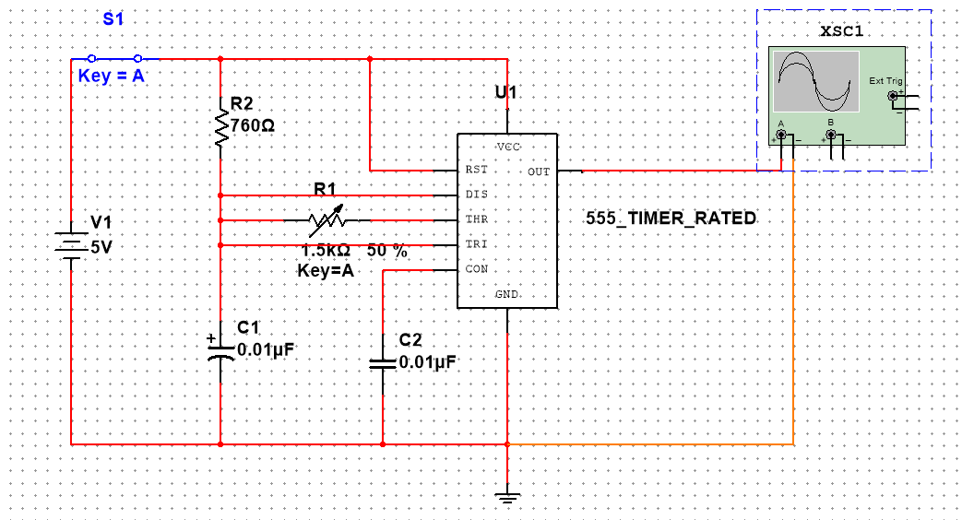

Figure 2 Ultrasonic Mosquito Repellent Schematic

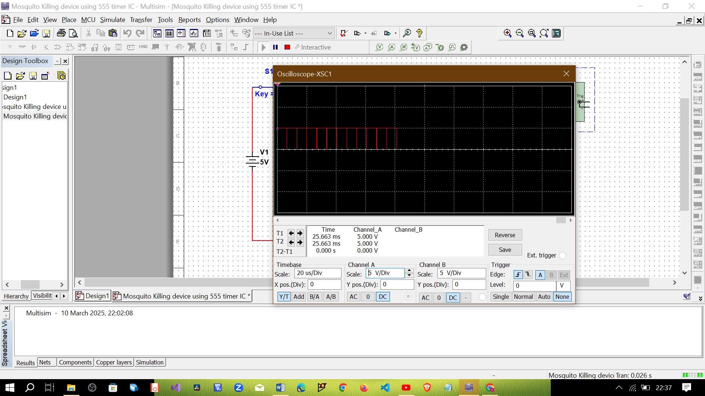

Figure 3 Output of Ultrasonic Mosquito Repellent

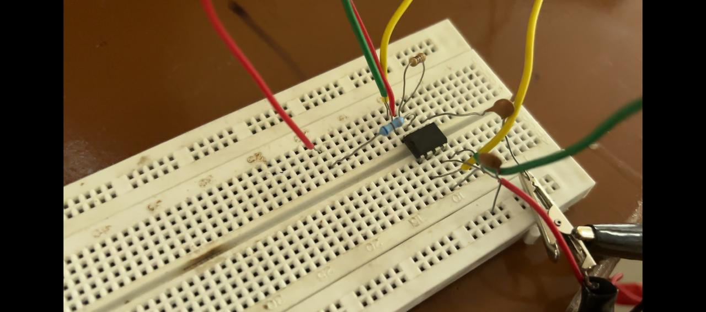

Figure 4 Breadboard Implementation

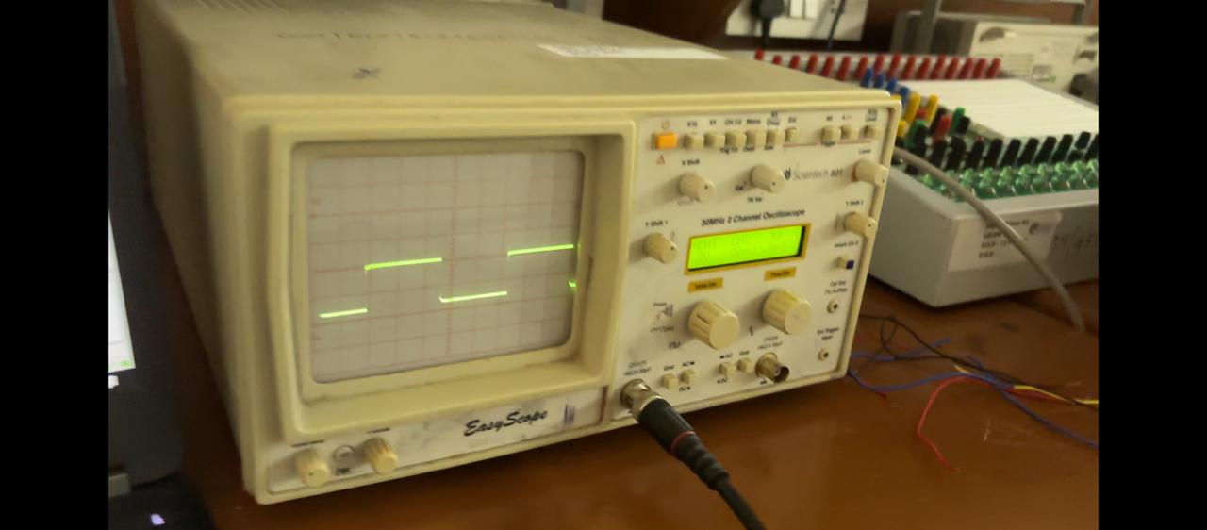

Figure 5 Output in Oscilloscope

* The circuit was constructed on a breadboard.
* The output frequency was measured using an oscilloscope.
* Testing was conducted in a controlled environment to assess the device's ability to repel mosquitoes.
* Due to the very nature of this product, it can be very difficult to test, and results could vary wildly.

# Applications:

* Household mosquito repellent.
* Outdoor activities (camping, picnics).
* Agricultural settings.
* Animal shelter

# Comparison with Other Methods:

* Chemical Repellents:
  + Pros: Highly effective.
  + Cons: Potential health risks, environmental impact.
* Mosquito Nets:
  + Pros: Very effective barrier.
  + Cons: can be inconvenient, does not repell outside of the net.
* Ultrasonic Repellents:
  + Pros: Non-toxic, environmentally friendly.
  + Cons: Variable effectiveness, limited range.

# State of Art

|  |  |  |  |  |
| --- | --- | --- | --- | --- |
| Technology/Method | Description & Mechanism | Period of Prominence | Price Range (INR) | Efficacy & Duration |
| DEET-Based Formulations | Topical application; disrupts mosquito olfactory receptors. | 1990-1995 | ₹50-₹150 (50-100ml) | High; 4-8 hours |
| Pyrethroid Mosquito Coils | Incense-based; releases insecticidal smoke. | 1995-2000 | ₹10-₹30 (coil pack) | Moderate; 6-8 hours |
| Electric Vaporizers (Mats/Liquids) | Electric heating; releases insecticide vapor. | 2000-2005 | ₹150-₹300 (device), ₹50-₹100 (refills) | High; 30-60 nights |
| Picaridin-Based Lotions | Topical application; milder synthetic repellent. | 2005-2010 | ₹100-₹250 (50-100ml) | Moderate; 6-12 hours |
| Essential Oil-Based Repellents | Topical/diffused; natural plant extracts. | 2010-2015 | ₹80-₹200 (50-100ml) | Low; 2-4 hours |
| Mosquito Nets (Untreated/ITNs) | Physical barrier; ITNs treated with insecticides. | 2015-2020 | ₹200-₹1500 | High; long-term (nets), 6 months (ITNs) |
| Ultrasonic Repellent (555 Timer Circuit) | Electronic device; 20-38 kHz frequency generation. | 2020-2025 | ₹150-₹350 (device) | Variable; limited range. |
| Spatial Repellents (Diffusers/Patches) | Volatile repellent release; air/patch-based. | 2020-2025 | ₹200-₹400 (diffuser/patches) | Moderate; 4-8 hours |

Table Mosquito Repellent Technologies

# Advantages:

* Non-Toxic and Environmentally Friendly:
  + Avoids harmful chemicals found in traditional repellents.
  + Reduces potential health risks for users.
  + Minimizes environmental impact.
* Cost-Effective:
  + Utilizes readily available and inexpensive components.
  + Offers a lower long-term cost compared to recurring chemical repellent purchases.
* Portable and Convenient:
  + Battery-powered design allows for easy portability.
  + Suitable for use in various locations, including outdoor settings.
* Quiet Operation (Relatively):
  + Produces ultrasonic sound, generally inaudible to humans.
  + Avoids noise pollution.
  + Some people or animals may be able to hear some of the produced frequencies.
* Potential for Continuous Operation:
  + Once constructed, and powered, the device can run continuously.

# Real-Time Applications:

* Developing portable, battery-powered units for personal use.
* Integrating the technology into existing home appliances.
* Implementing large-scale repellent systems in agricultural areas.

# Reference

* <https://github.com/SriSagarA/Ultrasonic-Mosquito-Repellent.git>
* <https://youtu.be/p3cBsjxp0x0?si=3NonQ9-2wLmoZmJr>

# Conclusion:

The ultrasonic mosquito repellent device offers a cost-effective and potentially safe alternative to chemical repellents. While its effectiveness is still a subject of ongoing debate, the simple circuit design and readily available components make it a viable option for personal use.